Joseph Silva Jr.

SNHU

DAD 220

04/19/2020

#1:

**Frequency of returns by state for all purchased products**

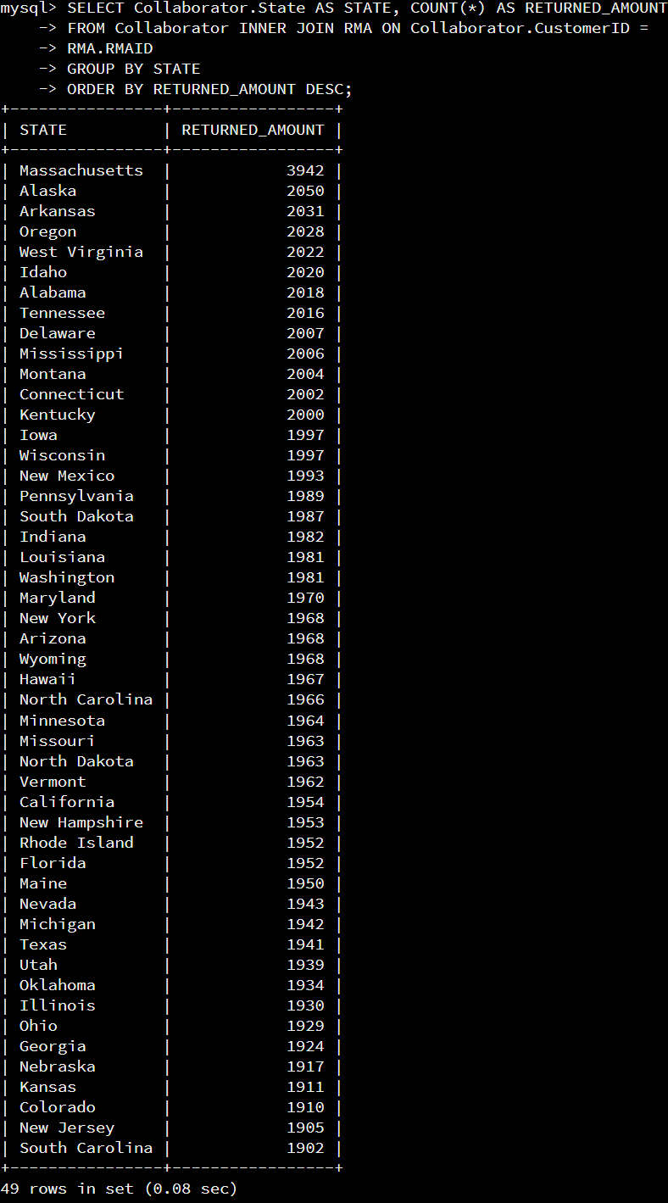

Looking at the photograph above, we can see the amount of returned product from each state in the U.S. The state with the highest amount of product returned to the company is the State of Massachusetts with 3,942 products returned. The state with lowest amount of product returned to the company is the State of South Carolina with 1,902 products returned. This gave us a total of 88,749 returned items in the U.S.

**Percentage of returns for all purchased products**

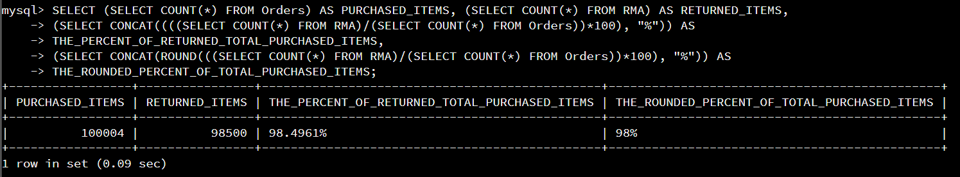

Looking in the above photograph, we can see the amount of purchased items, amount of returned items, and the percentage ratio of returned items to purchased items. The total amount of purchased items was 100,084, but the total amount of returned items was 98,500. To find the percentage, we divide the total amount of returned items by the total amount of purchased items (98,500/100,084) and then multiple by 100; This calculation gave us 98.4961% or rounded to 98%. These numbers mean 98% of our purchased items are being returned to the company by its customers.

#2:

This data can show the management that we are losing revenue on 98% of the purchased items because the customers are returning 98% of the purchased items from this company. The flaws with this data that are presented is the total amount of returned items (98,500) do not match with the total amount of returned items from each state in the U.S. (88,749). There can be reasons for these difference in results such as deleted records, inputting incorrect records, late update of records, or there could be a different timeline for collection of each csv. files.